Controlled Assessment Practice Task
Population Model

Scenario: A Population Model
When studying the environment, scientists sometimes look at how population sizes of animals and plants change over time. The scientists can use this information to find out which species are in danger of becoming extinct, to predict the effect of introducing a foreign species of animal into the countryside, or to discover the effect of a pollutant.
Studying populations of animals and plants in the wild can take a very long time, so scientists use computer models to help them in their studies.
You have been asked to create a simple population model to investigate how a greenfly population changes. Greenflies are a common insect that are considered to be a pest by gardeners because they damage roses and other garden plants.

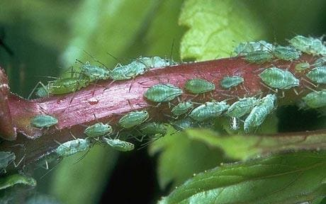

The life cycle of greenfly is complex and the model you have been asked to create will model only some aspects of the greenfly life cycle. In the summer, the population consists only of females and each female gives birth only to females.

The Population Model rules
To create a population model, the following rules must be followed.

- The population consists only of females.

- At any one time there are three types of individual in the population:
- Seniles – old greenfly that do not reproduce
- Adults – greenfly that are reproducing
- Juveniles – greenfly that are too young to reproduce.
- The model lasts for a set number of new generations. At the end of each generation:

- all surviving senile greenfly remain as seniles

- all surviving adult greenfly change from adults to seniles

- all surviving juvenile greenfly change from juveniles to adults.

- Each type of individual has a survival rate. The survival rate is used to calculate the number of individuals that survive at the end of each generation. This number can be a value between 0 and 1.

- A survival rate of 0 means no individuals of that type survive at the end of the generation.
- A survival rate of 1 means all the individuals of that type survive at the end of the generation.
- A survival rate of 0.25 means that a quarter of the individuals of that type survive to the next generation.

The number of individuals surviving to the next generation is calculated using the formula:

New number of individuals = Current number of individuals * survival rate

- Adult greenfly have a birth rate. The birth rate is used to calculate the number of juveniles that adults produce each generation. This number can be a fraction, so a birth rate of 1.5 means that, on average, each adult produces 1.5 juveniles each generation.

The number of juveniles born each generation is calculated using the formula:

New number of juveniles = Current number of adults * birth rate

- Numbers of individuals in the model are measured in thousands.

- The following values must be set before the model is run:
- the initial numbers (called Generation 0) of juveniles, adults and seniles.
- the birth rate and survival rates.
- the number of new generations over which the model runs. This must be between 5 and 25.

Example data
Table 1 and the Data below shows the data that are used by the model to generate the results in Table 2.
Table 1
Type of Green Fly | Initial Population | Survival Rate
Juvenile | 10 | 1
Adult | 10 | 1
Senile | 10 | 0

Number of new generations = 5
Birth rate = 2

Table 2
Generation | Juveniles | Adults | Seniles | Total
0 | 10 | 10 | 10 | 30
1 | 20 | 10 | 10 | 40
2 | 20 | 20 | 10 | 50
3 | 40 | 20 | 20 | 80
4 | 40 | 40 | 20 | 100
5 | 80 | 40 | 40 | 160

Planning Task
- Develop a flowchart as a plan for your program. Think carefully about what you want it to do and how the data should move through the software. This will help you create a working solution and should be complete before you start writing code.

Programming Tasks

- Develop a main menu for the program. The options on the main menu should be:
- Set Generation 0 Values
- Display Generation 0 Values
- Run the Model
- Exit

- Develop the part of the program that allows the user to set the Generation 0 values for the:
- Population numbers of juveniles, adults, seniles
- Survival rates for juveniles, adults and seniles
- Birth rate
- Number of generations to model. This should be between 5 and 25

The program should then return to the menu.
- Develop the part of the program that will display the Generation 0 values for juveniles, adults and seniles, the birth rate and the survival rates. The program should then return to the menu.

- Develop the part of the program that runs the model, displaying the number of juveniles, adults and seniles and the total population size for each generation from 0 to the number of new generations entered. The program should then return to the menu.

- Develop the part of the program that exits

